📬 Submit this assignment by Monday, September 21st at 2:59AM EDT using the Submit button 👉

Unit 1: Project 1 - Listicle Part 1

Overview
Who doesn't love a good list? In this project, you'll create a list-based web app that displays content of your choosing. Is it a guidebook to finding the best local music venues? 🎶 Is it a database of tips and tricks for young entrepreneurs? 💼 You'll create a web app that displays some interesting data in a list, building out a complete backend that serves static HTML, as well as a minimal frontend to serve the data.
👋 Keep in mind that in this project, you should not use a frontend framework, like React. Instead, use vanilla HTML/CSS/JS and Picocss to style your app.
💡 In Unit 2, you'll connect your app to a database. Make sure all items in your Listicle project have a few shared attributes. For example, in the Unearthed lab, each gift has a name, price point, description, and so on. See the examples below for more help.

Example App 1: Discover Local Music
Love live music? This app helps students find upcoming concerts, open mic nights, and music festivals happening near their college or university. Whether you're into indie, hip-hop, EDM, or acoustic sets, you can filter by genre, ticket price, or venue size. Users can click on an event to see more details, like the artist lineup, date and time, and ticket price.
Event shared attributes: event name, artist(s), date & time, venue, genre, ticket price (if applicable)

Example App 2: Guide to Starting Your Business
No matter what stage you are at opening up a business, we have a tutorial for you! Looking to brainstorm business ideas and find your niche? We can guide you in the right direction! Finding the right partner? Growing your team? Talking to suppliers? We have a short guide for each one of those. Our guides are sorted into different categories (including business models, product development, sales, market research, and funding) so you can browse or filter to personalize your experience.
Business tip shared attributes: title, text, category, image, submitted by
Use AI to brainstorm ideas for your code
If none of the above ideas inspire you and you don't have any ideas of your own, you can also ask Copilot (or ChatGPT) for additional project ideas! Provide Copilot with a description of the project and its requirements as well as a list of your interests. Then ask it to generate a list of possible project themes and shared attributes!

🎯 Goals
By the end of this assignment you will be able to...
- Create a web server to handle incoming requests
- Create routes and request handlers using Express

Required Features
- The web app uses only HTML, CSS, and JavaScript without a frontend framework
- Front page of web app is functional and appropriately styled
  - The web app displays a title
  - Website displays at least five unique list items
  - Each list item includes at least three displayed attributes, such as a title, description, and image

- Each list item has a corresponding page
  - The user can click on each item in the list to see a detailed view of it, including all database fields
    - e.g., localhost:3000/bosses/crystalguardian and localhost:3000/mantislords

  - The web app serves an appropriate 404 page when no matching route is defined

- The webpage is styled with Picocss

Screenshot
View an exemplar of the project here!
A simple version of the app with all the required features implemented:
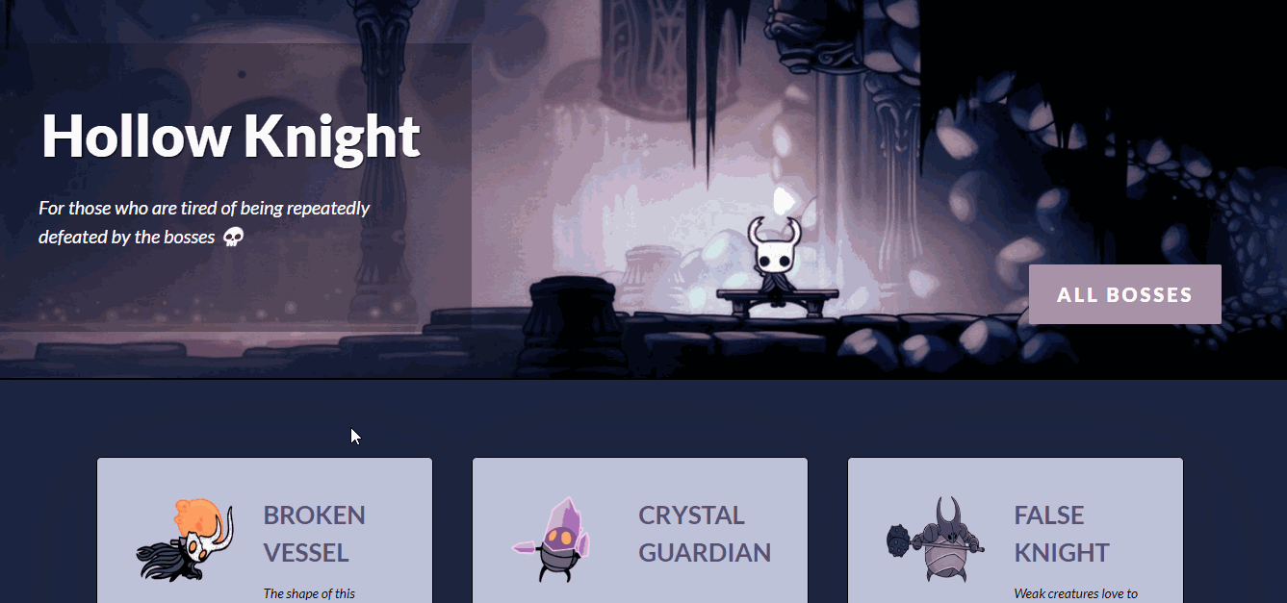

Stretch Features
- List items are displayed in a unique format
  - e.g., cards rather than lists or animated list items

Resources
- MDN Web Docs: HTML
- MDN Web Docs: CSS
- Picocss
- MDN Web Docs: JavaScript
- Express Routing
- Express Basic Routing

💡 Hints
- Help! I don't know where to start!
  - After you decide on your topic, decide what information you want to display and how you want to display it on your web app. Then, figure out your routes and structure your pages.
  - Look at this week's lab for examples on how to implement similar applications. What code will be similar? What do you need to change?
- I'm stuck on something!
  - Don't just skip the Resources section.
  - Review the AI debugging tips in the box below!
  - Still need a little extra help getting started or running into an error? Try posting in the Class Slack Channel.
Use AI to understand why your code isn't working
📣 Submission Guidelines: For more details on submission instructions, follow the guidelines on the Submitting Coursework page.
- Make sure you are adding and committing files in git as you complete features and milestones.
- Be sure to include a README containing a GIF walkthrough of your project.
- Use this README TEMPLATE.
  - It is important that you follow the same layout as the README template so that we can easily access your work.
  - Be sure to check off each feature that is implemented in your submission by changing [ ] to [x]. We won't be able to assign points if a feature is unchecked.
Note: We highly encourage you submit your project in any state (even if it is not done) by Monday, September 21st at 2:59AM EDT. You can continue to work on your project with our 48-hour extension* in which your project will be graded once more once the extension deadline has passed (see "Coursework Submissions" in Syllabus for details). Don't forget to resubmit through the course portal with your updated GIF recording!

Project Grading

Project 1: Listicle Pt. 1
Total Points: 17pts + 2pts bonus
Required Features | Points
The web app uses only HTML, CSS, and JavaScript without a frontend framework | 2
Front page of web app is functional and appropriately styled | 7
Each list item has a corresponding page | 6
The webpage is appropriately styled with Picocss | 2
Total | 17

Stretch Features | Points
List items are displayed in a unique format | 2
Total | 2

Submitting Coursework
Once you've completed the required features for your project, take the following steps to get your project ready to submit.

Steps to submit a project

🎯 Push Code to Github Repository
- If this week's project is starting a new app, you will have to create a new Github repo.
- However, if the week's project is a continuation of the last week's project (E.g. Pair Cards Part 2), you will NOT create a new Github repo and will instead just push your new code.
- Checkout this Submitting Through Github Walkthrough if you're not too familiar with Github yet.

🎯 Create a README Template
- Every submission must be accompanied by a README.md using the readme template provided with the project to demonstrate which required and optional tasks you've completed.
- In your project repository, add a README.md file in the root directory that contains the contents of the README template for that project.
- If the project is a continuation of the same app as the previous week, add the new template to the end of the previous README instead of creating a new file.
- Make sure to check off the user stories you've completed.

🎯 GIF Walkthrough
- Your README.md must contain a GIF walkthrough using a recording program of your choice. It should demonstrating how it works with the user stories completed.
- We recommend using Kap for macOS, ScreenToGif for Windows, and peek for Linux.
- Imgur is a great service for hosting the GIF walkthrough and then linking to it from the README.
- When using Imgur, you can right-click on the gif and choose "Copy Image Address" to get the correct address. Make sure the address has a .gif extension. If you end up with a url that has a .gifv extension, removing the v and changing this to .gif will ensure the gif renders on GitHub.
A GIF / Video of your app is a Requirement for getting credit -- Just screenshots are not enough!

🤔 GIFs not your thing? You can also follow this Video Submission Guide to record and embed a video of your app using Loom!

🎯 Make sure you've pushed all your latest code up to GitHub
- To check this, you can browse your repository on GitHub on your favorite browser to make sure some of your latest changes are present there.

🎯 Make Repository Private & Add CodePath review as collaborator
- Every submission must be submitted in a private repository.
- Check out this Guide on making your repository private.
- Because the repository will be private we must also add the the CodePath review github account as a collaborator.
- Check out this guide on adding the CodePath review github account as a collaborator.

🎯 Submit Project
- Once you have completed all required user stories and added a README as described above go to the Project Tab for the project and click the Submit button on the right-hand side.
- 🏞️ Click for Screenshot
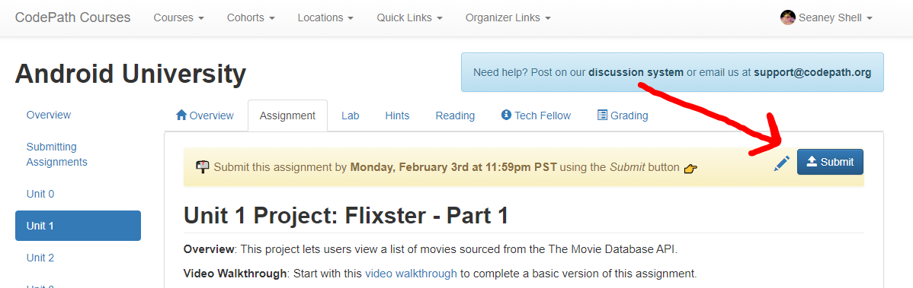
- In the dialog that appears, enter the required information about your project
- 🏞️ Click for Screenshot
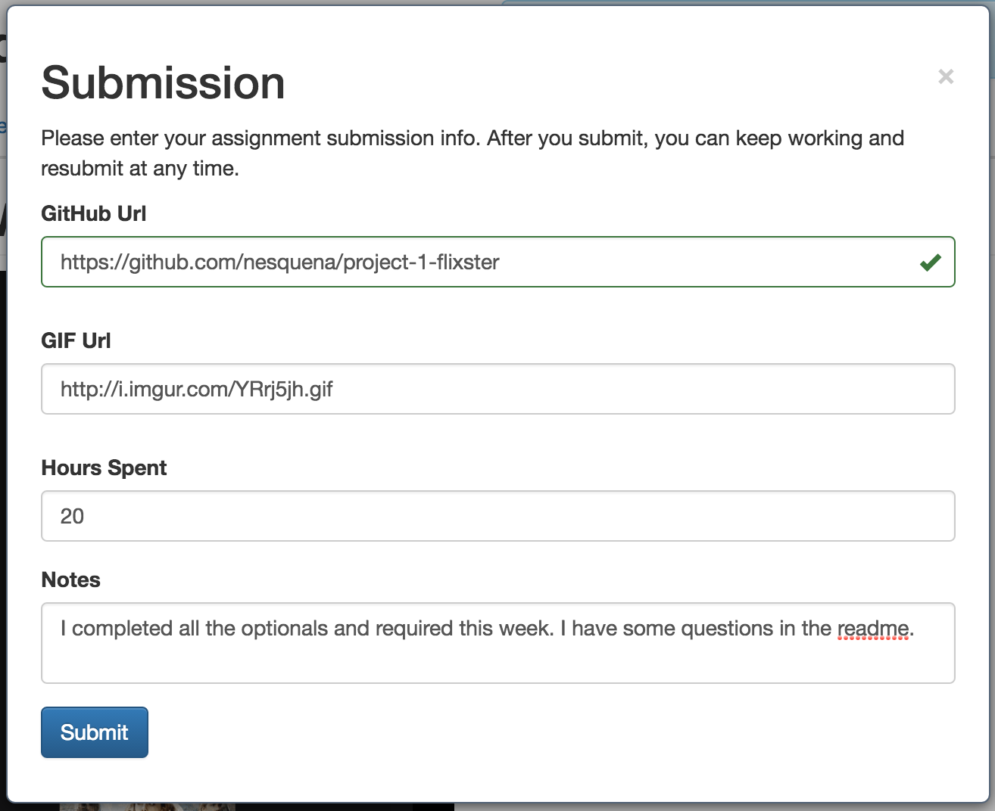
- Then press "Submit" at the bottom to finalize your submission. Note that you can always update your submission at any time in case you want to re-upload the GIF or update the hours spent.
⚠️ NOTE: If you recorded your app walkthrough as a video file instead of a GIF, check out this submission guide for embedding the video into your README.

✅ Ensuring your Submission is Valid
To ensure you get credit for your submission, review the following items:
- Can you see your latest code on GitHub?
- Does your README use the provided readme template?
- Did you include a GIF / Video walkthrough? (NOT only screenshots!)
- When going to your main repository page on GitHub, can you see your README and does your GIF/Video walkthrough start playing?
- Does your app have all of the required features?
Great work! You've submitted your project! 🎉📬🎉
Video submission link: https://www.youtube.com/watch?v=GA92eKlYio4

